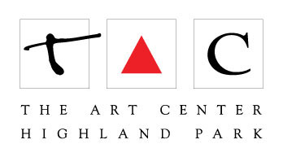
355 - Imaginary Travel: Painting Your Way Around the World

Sandie Bacon

sandiebacon1@gmail.com

Set of Acrylic Paints: Golden Heavy Body Artist Acrylic Set or Introductory Set of 6or equivalent.

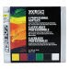
Ideal for beginners and artists on the go, this compact set includes 0.75 oz (22 ml) tubes of Benzimidazolone Yellow Medium, Mars Black, Naphthol Red Light, Permanent Green Light, Titanium White, and Ultramarine Blue.

NOTE: Teacher will supply a few gels and pastes to be picked up.

4 small canvases (8 x 10” or 9 x 12”) Or 4 small Ampersand panels (same dimensions)

A variety of acrylic brushes

Pencils

Paper to sketch with (i.e. copy paper)
Pet Image to work from.

