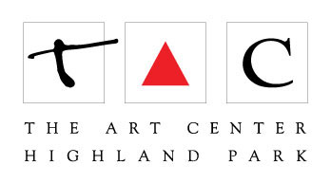
350B - Portraiture - Part 2: Acrylic Painting

Terry Luc

terryoluc@gmail.com

Paints: Golden acrylic paints
Colors: Titanium White
Mars Black
Burnt Sienna
Napthol Red Light
Hansa Yellow Medium
Phthalo Blue (Green Shade)
Dioxazine Purple -optional

This is the basic color set. Artist can of course add any other paint colors that they would like. And please note that Dioxzaine purple is optional.

Brushes: two (2) small sable brushes. One (1) medium size flat brush. One (1) large flat brush.
Golden Soft Gel Gloss
At least one Canvas or canvas board; recommended sizes (any one is fine): 8x10, 9x12, 11x14, or 16x20

