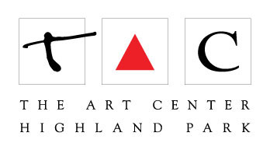
350A - Portraiture - Part 1: Black and White Drawing

Terry Luc

terryoluc@gmail.com

- Large Drawing pad (i.e. 18x24inches) – Newsprint is fine. High quality drawing paper is better.
- Preferred drawing tools: black crayon, charcoal, chalk, or drawing pencils

Probable costs: $20

